**PROJECT REPORT**

By:

Pooja Sreenivasan,

T.K.M. College of Engineering, Kollam,

Year-1,

Branch-Computer Science and Engineering.

# ML Project-

The project is a weather predicting model that predicts the average temperature of a given year in India.

Input: A year

Output: Average Temperature in Celsius

Dataset used: Weather data in India from 1901 to 2017.csv

# ML Model-

Link for .ipynb notebook- <https://colab.research.google.com/drive/1b4vU7R4ggXtWNFhL03hhc19x9s-RyiEQ?usp=sharing>

Python code:

import pandas as pd

df=pd.read_csv('/content/sample_data/Weather Data in India from 1901 to 2017.csv')

df=df.drop(columns='Unnamed: 0')

df

x = df.iloc[0:118,0].values

x=x.reshape(-1,1)

x

y = df.iloc[:,13].values

y

from sklearn.model_selection import train_test_split

x_train,x_test,y_train,y_test = train_test_split(x,y,random_state = 0)

from sklearn.linear_model import LinearRegression

model = LinearRegression()

model.fit(x,y)

model.fit(x_train,y_train)

# Deployment

Deployment of the model is done using Heroku and Streamlit.

Heroku is a cloud platform that developers use to deploy, manage and scale modern apps.

# Steps of Deployment

A file called ‘Weather Prediction’ is created and the machine learning model is saved to it used joblib module.

import joblib

joblib.dump(model,'Weather Prediction')

For temporary deployment:

!pip install streamlit –quiet

%%writefile app.py

import streamlit as st

import joblib

model = joblib.load('Weather Prediction')

st.title('WEATHER PREDICTOR')

ip = st.text_input('Enter a Year',value=0)

op = model.predict([[ip]])

if st.button('Predict'):

  st.title(op[0])

!streamlit run app.py & npx localtunnel --port 8501

Running this provides a URL that leads to the app.

For Permanent deployment:

Go to the Heroku site and login to your account. Select on create new app and connect Heroku with your github account. Deploy the app.

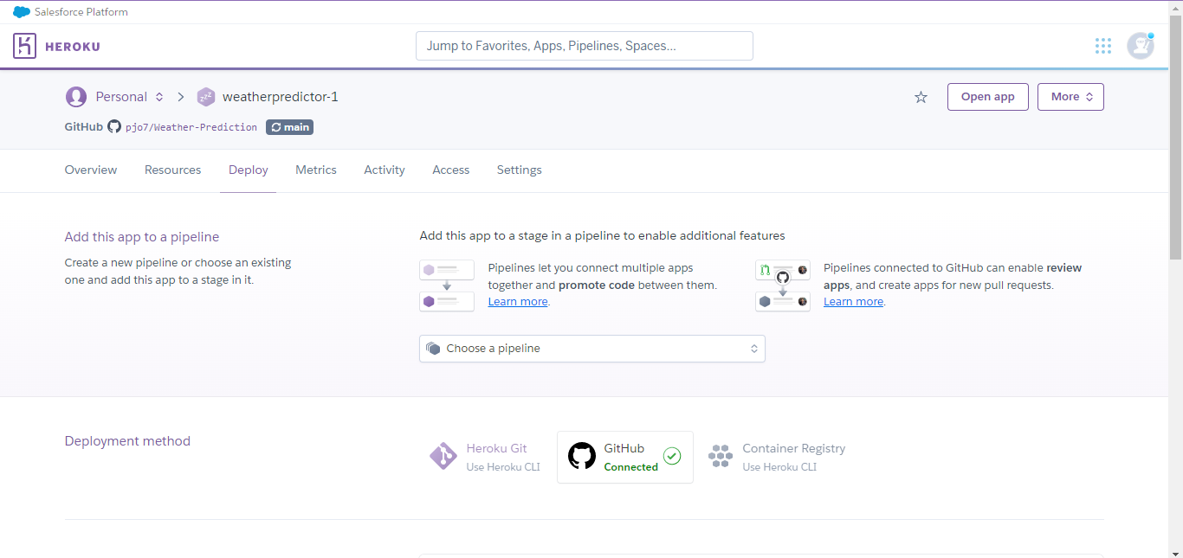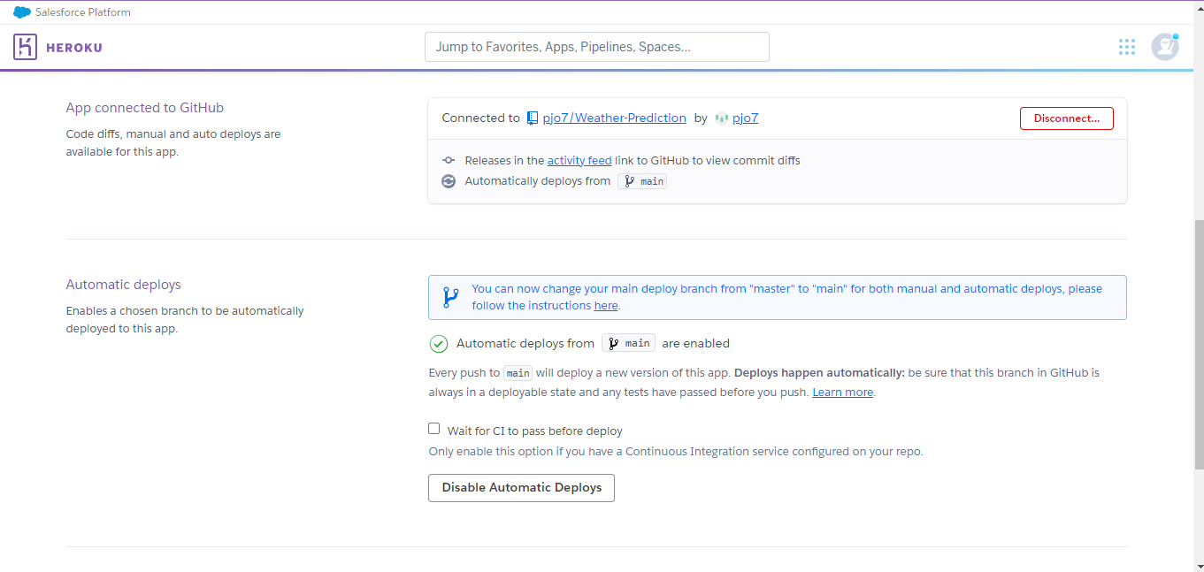

A link is provided at the completion that leads to the app.

# Streamlit App

